Zach Smith
Network+ part 2
TLS handshake lab

Part1/2
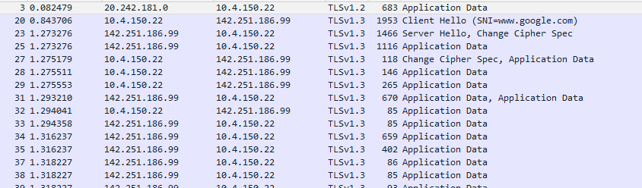

Part 2 step 1:
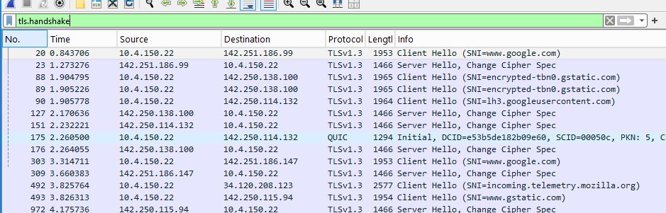
Questions:
1. The TLS version proposed by the client is v1.3 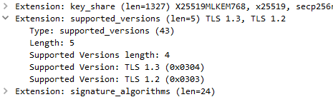
2. 17 cipher suites are offered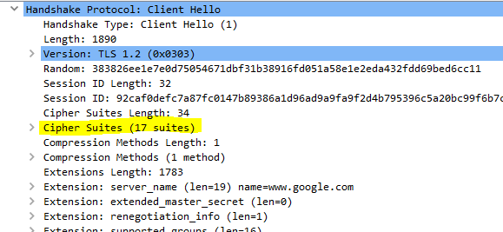
3. The random value is important to ensure session uniqueness. This prevents attackers from reusing captured handshake data.

Step 3: serverhello
4. The server selected AES128
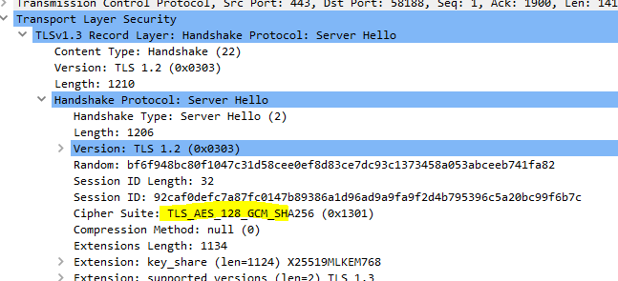
5. Yes, the server supports 1.3 as well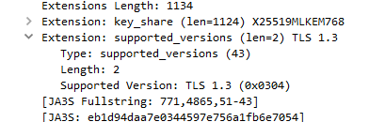

Step 4:
Interestingly, I didn’t see any certificate data from google. WSUtech does though
6. Microsoft secure server ca 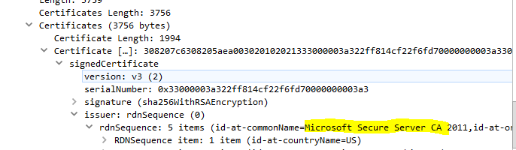

7. Microsoft Corporation
8. May 17 2025 – may 17 2026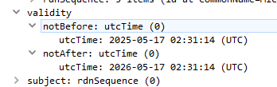

Step 5:
9. Diffie-Hellman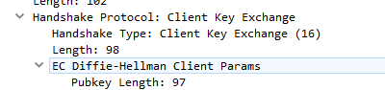
10. Ephemeral is preferred because it provides perfect forward secrecy (PFS) and it is a modern security standard.

Step 6:
11. After the encrypted handshake 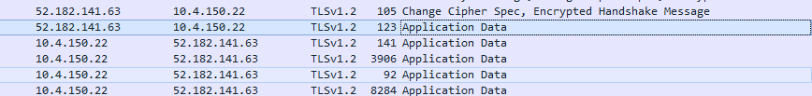
12. I didn’t find any finished packets in the wireshark capture. However it is important because it contains a hash of all previous handshake messages. This proves that the handshake was not tampered with.

Reflection:
The TLS handshake ensures that both the client and the server have agreed to communicate on a set protocol, with an agreed upon encryption message, with shared keys. It also authenticates the server (optionally the client) through digital certificates.
TLS ensures security by guaranteeing confidentiality through encryption with unique session keys. It also guarantees integrity and authentication with message authentication codes and verifies identity with digital certificates and public key cryptography.

